WHEEL OF THE FUTURE – CONSEQUENCE MAP
Enter the starting point in the center. Write the direct effects in the first ring, and subsequent consequences in the rings that follow. Use the outer blue ring to mark the most important opportunities or risks.
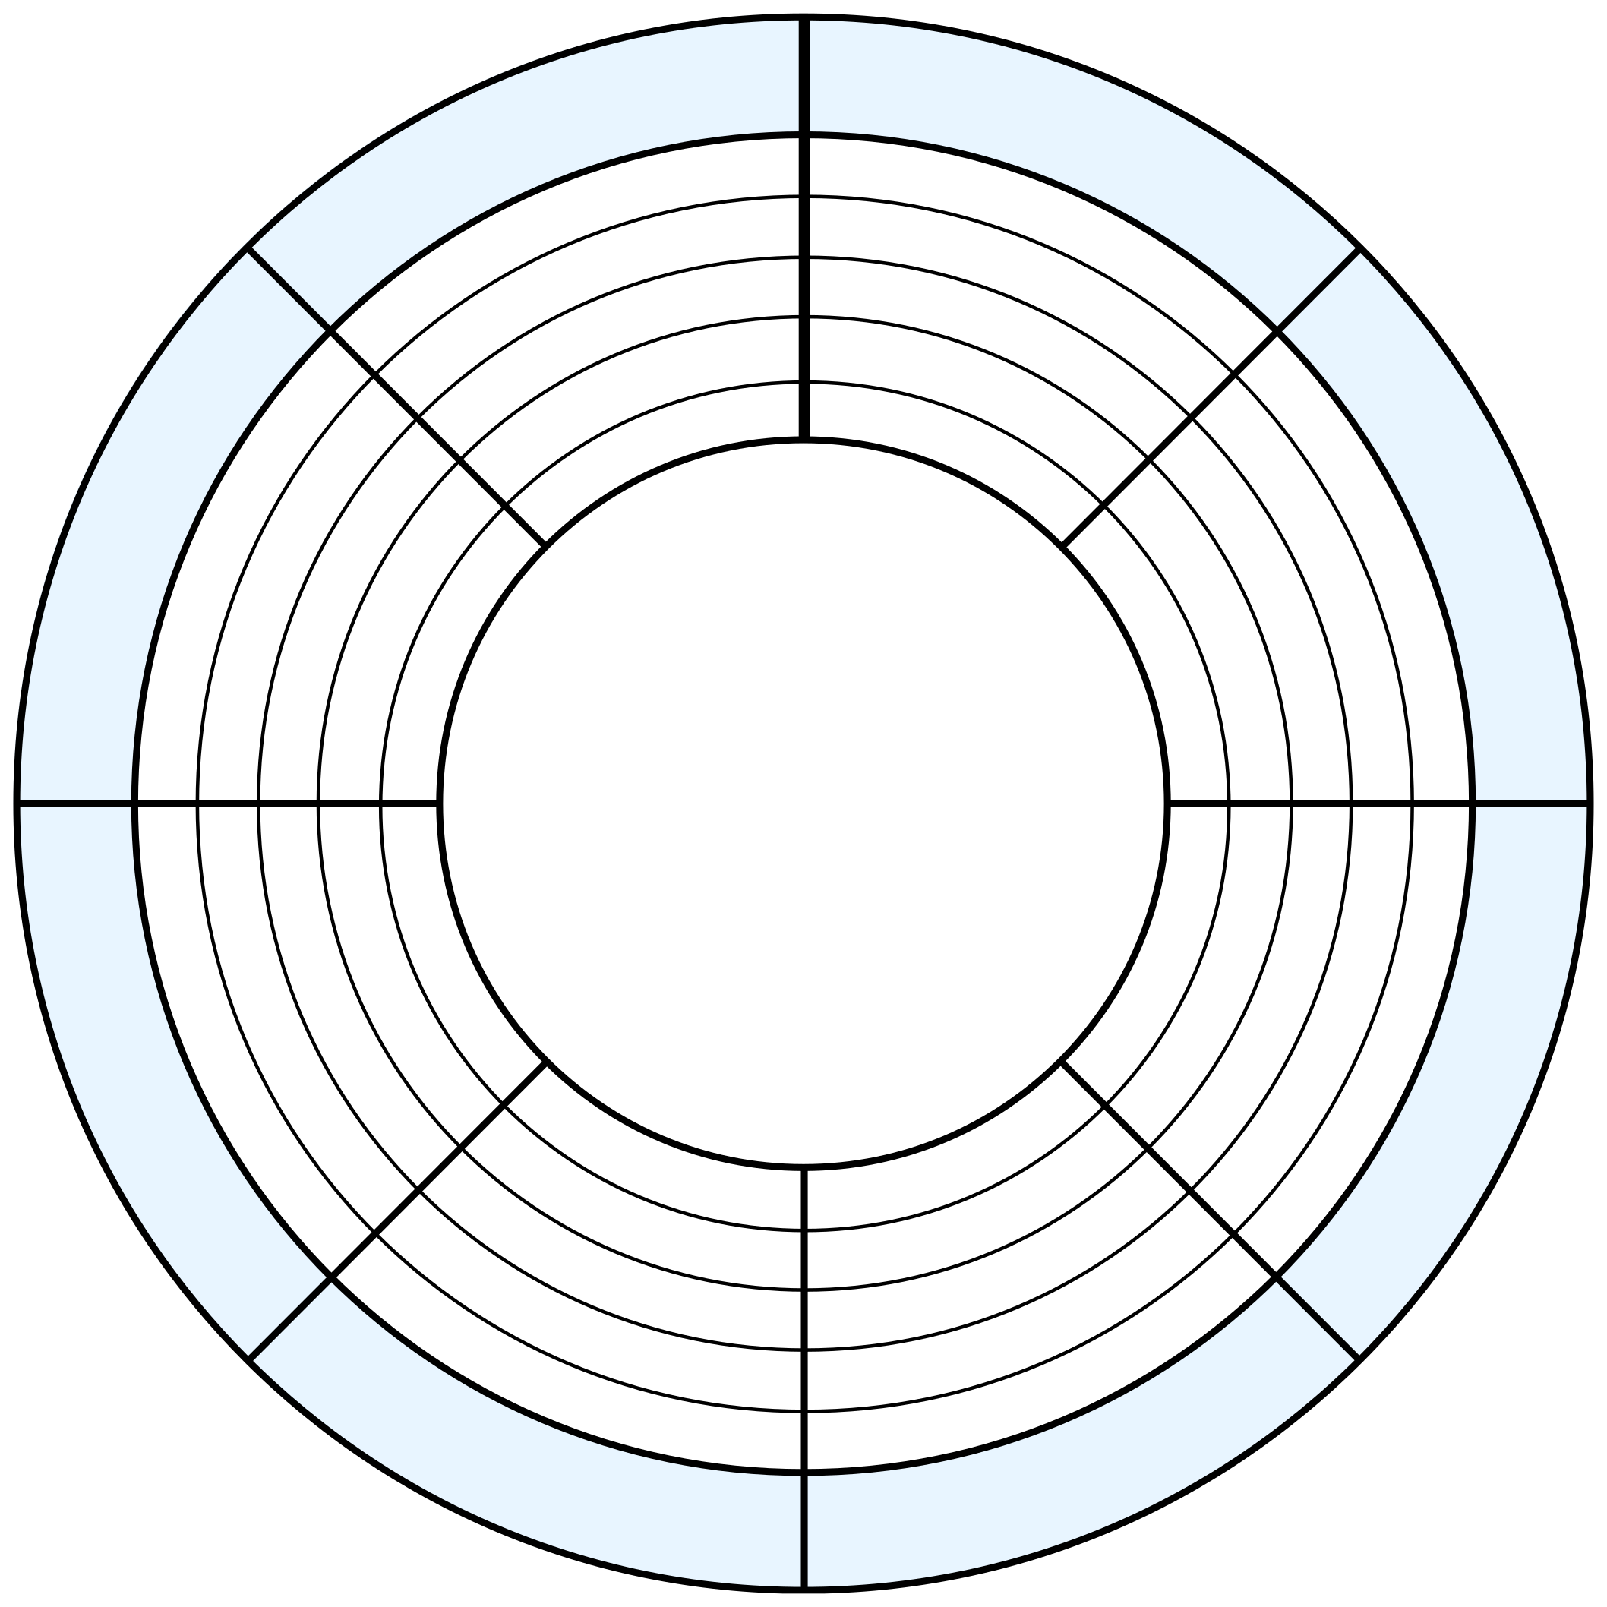
ASSESSMENT OF CONSEQUENCES AND CONCLUSIONS
Select the most important elements from the wheel. Rate them on a scale of 1 to 5, where 1 indicates a very low level and 5 a very high level.

No. | Consequence | Character  + / – / ± | Probability  1–5 | Meaning 1–5 | Justification
1
2
3
4
5
6
7
8

Summary

The most important conclusion | The greatest opportunity or risk | Recommended  action
Question: Which action taken today could most significantly influence the future course of the situation under analysis, and why?

